**Name: Parmita Patre**

**Class: Final Year CSE Div: B**

**Roll: B_58**

**Assignment 5**

**Problem Statement:** Automate Deployment using Jenkins plugin “Deploy to container”.

The “Deploy to Container” plugin in Jenkins enables seamless and automated deployment of web applications directly to application servers like Apache Tomcat. By integrating this plugin, Jenkins can automatically deploy a WAR (Web Application Archive) file to a specified container after the successful build of an application, making the continuous integration and continuous deployment (CI/CD) process smoother.

**Jenkins Screenshots:**

Created a job TestDeployToContainer:

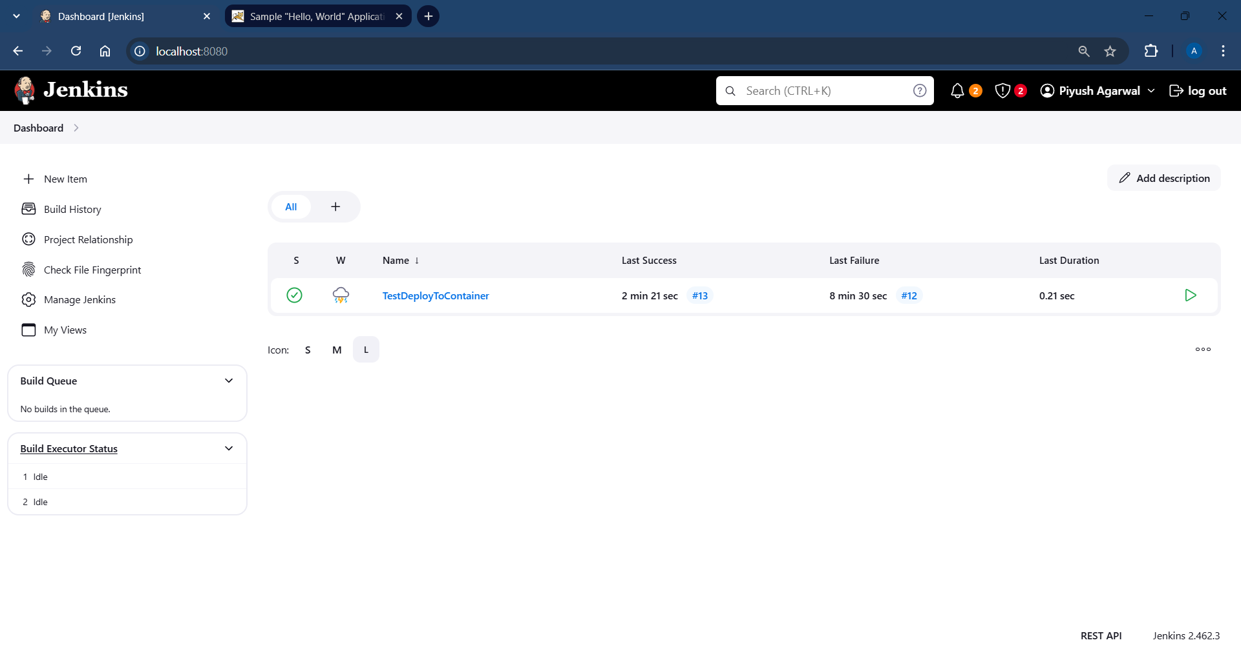

Build step for the job:

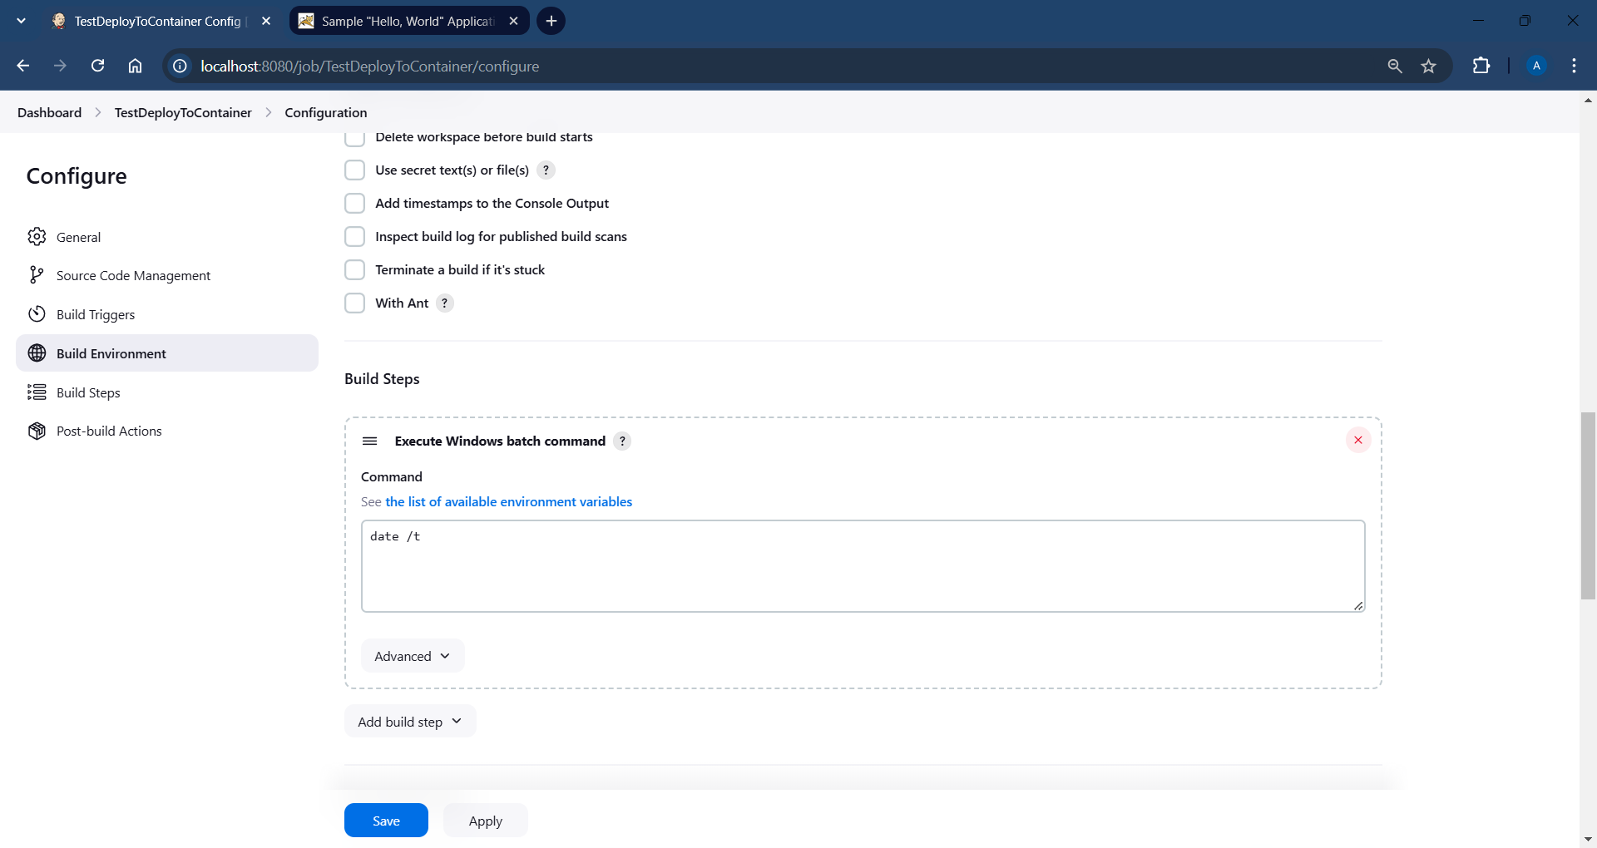

Post-build Actions for the job:

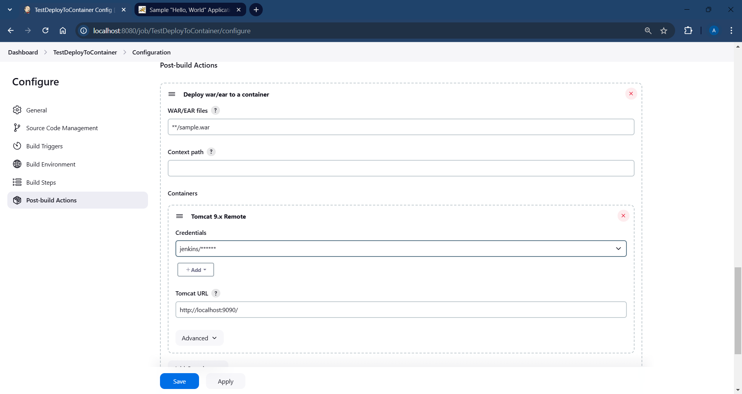

Building the job:

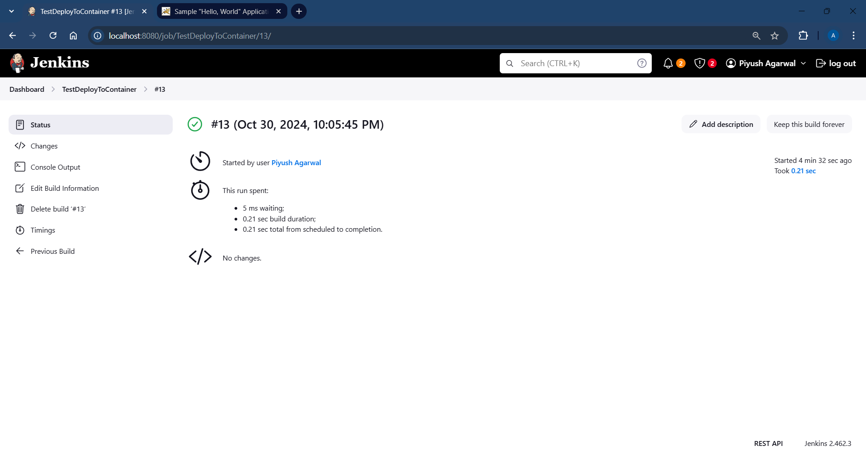

Console Output for the job after build is complete:

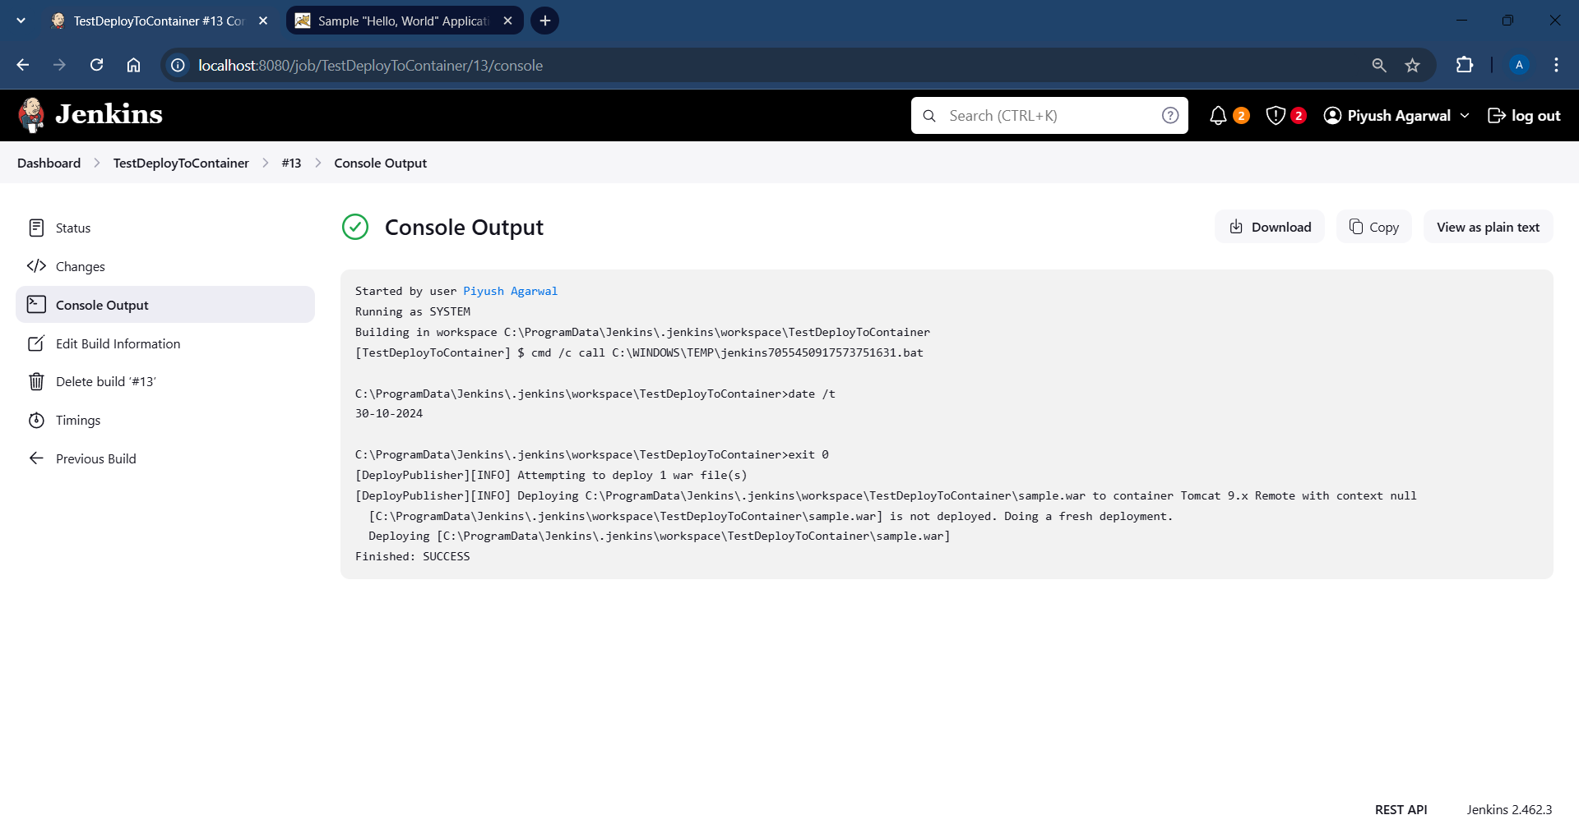

**Tomcat Screenshot:**

Going to <http://localhost:9090/sample/>

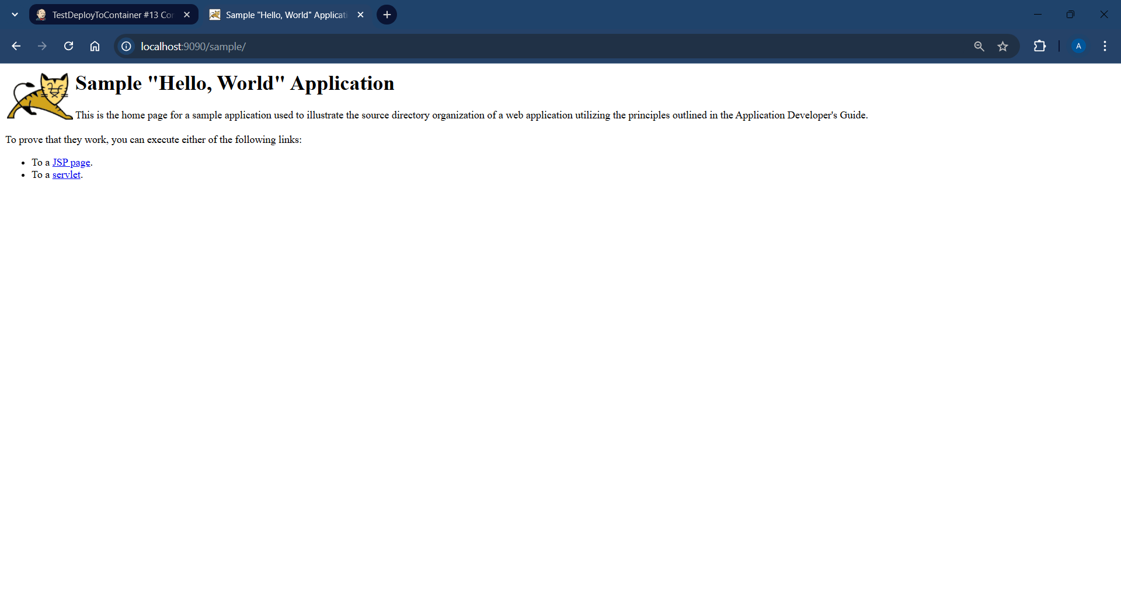

**Conclusion:**

Using Jenkins with the "Deploy to Container" plugin offers an efficient solution for automating deployments. This setup enhances productivity by enabling quick deployments to production or test servers, reducing potential errors from manual deployment, and enabling frequent releases. In this assignment, the deployment of a sample WAR file was automated to an Apache Tomcat server, demonstrating how CI/CD can simplify and accelerate application delivery.